This week you MUST do #1-4 and #5 is your optional choice this week. Everything is combined now into one document. The descriptions are first and then directions below this chart. Any and all photos, paragraphs, and required responses will need to be included on this form. Share this form ONE TIME at the end of the week when ALL activities are completed.

|  |  |  |  |  |
| --- | --- | --- | --- | --- |
| #1 | #2 | #3 | #4 | #5 |
| REQUIRED  Review Equipment Slides | REQUIRED  Kitchen Equipment Inventory and Categorizing | REQUIRED  Recipe Reading | REQUIRED  Equipment ID Quiz | OPTIONAL  Make Something! |

|  |
| --- |
| #1 – Equipment Slides: Use the link on the webpage to learn and review common kitchen tools and equipment and how they are used.    #2 – Inventory and Categorizing: Look through your kitchen and follow directions for the #2 labeled section below.  #3 – Recipe Reading: Use the recipe provided and follow directions for the #3 labeled section below.  #4 – Quiz Time: After you have read and reviewed the equipment slides, close that information and do your best on the quiz questions in the #4 labeled section below.  #5 – Make Something: I would love to see you in action. Find a recipe that you and your parents are comfortable with you preparing. Insert or type the recipe into the #5 labeled section AND include pictures of your delicious dish! I really, really, really hope you choose to do this part. I want to see yummy food. |

REQUIRED #2:

Look in your kitchen and choose a minimum of 20 different tools or pieces of equipment that are used to make food. When you have your chosen items, type the name of the item below the category heading where it belongs. Example: Microwave should be listed under Small Appliances.

**Small Appliances: (Things small enough to sit on your counter or be hand held)**

**Measuring Tools:**

**Cutting and Spreading Tools:**

**Mixing Tools or Equipment:**

**Lifting and Turning Tools:**

**Draining and Straining Tools or Equipment:**

**Baking and Cooling Tools or Equipment:**

**Cookware and Bakeware Equipment:**

**Tableware:**

**Clean Up Tools:**

REQUIRED #3:

Recipe Reading Instructions: Use the Apple Cinnamon Streusel Muffin Recipe below to complete this section. List all cooking tools and equipment in the recipe and explain in detail how the item is used in the recipe.

Apple Cinnamon Streusel Muffins

# Apple Cinnamon Ingredients: Chocolate Chip Ingredients:

|  |  |  |  |
| --- | --- | --- | --- |
| 2 c. | Bisquick Mix |  | 1 c. Flour |
| 1/4 c. | Sugar |  | ¼ c. Sugar |
| 1 tsp. | Cinnamon |  | 1 ½ t. Baking Powder |
| 1 | Egg |  | ¼ t. Salt |
| 1/3 c. | Applesauce |  | 1 Egg |
| 1/4 c. | Milk |  | ¼ c. Milk Plus 2 T. |
| 2 T. | Vegetable Oil |  | ¼ c. Applesauce  1/3 c. Mini Chocolate Chips |

# Directions:

* Preheat oven to 400°F. Spray muffin tin with non-stick cooking spray.
* In a mixing bowl stir all dry ingredients for muffins together with a wire whisk and make a well in the center.
* In a separate bowl mix all wet ingredients for muffins until blended well and add to dry ingredients and stir until just moistened. Divide evenly among 6 muffin cups, filling 3/4 full.
* Bake 18-20 min or until toothpick comes out clean. Cool 5 min and remove from pan on to a cooling rack.

**Equipment Needed:** (Minimum of 8 items) **How it is Used in Recipe:**

REQUIRED # 4:

Equipment Identification Quiz: Do your best WITHOUT looking back at the equipment slides.

1. 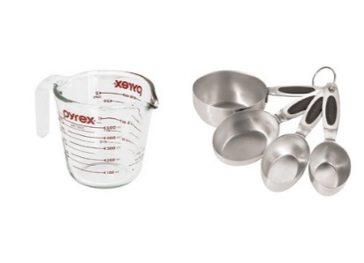 2. 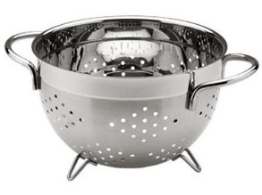 3. 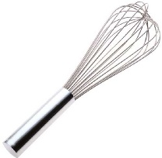 4.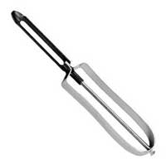

5.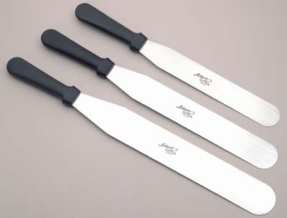 6.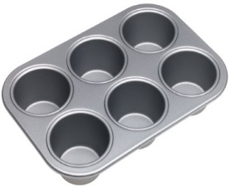 7.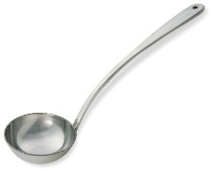

8.  9. 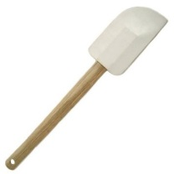 10. C:\Documents and Settings\brennanst\Local Settings\Temporary Internet Files\Content.IE5\UVG3B1ZZ\MC900341000[1].wmf11. 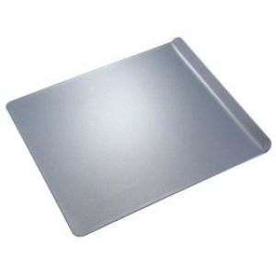

12. 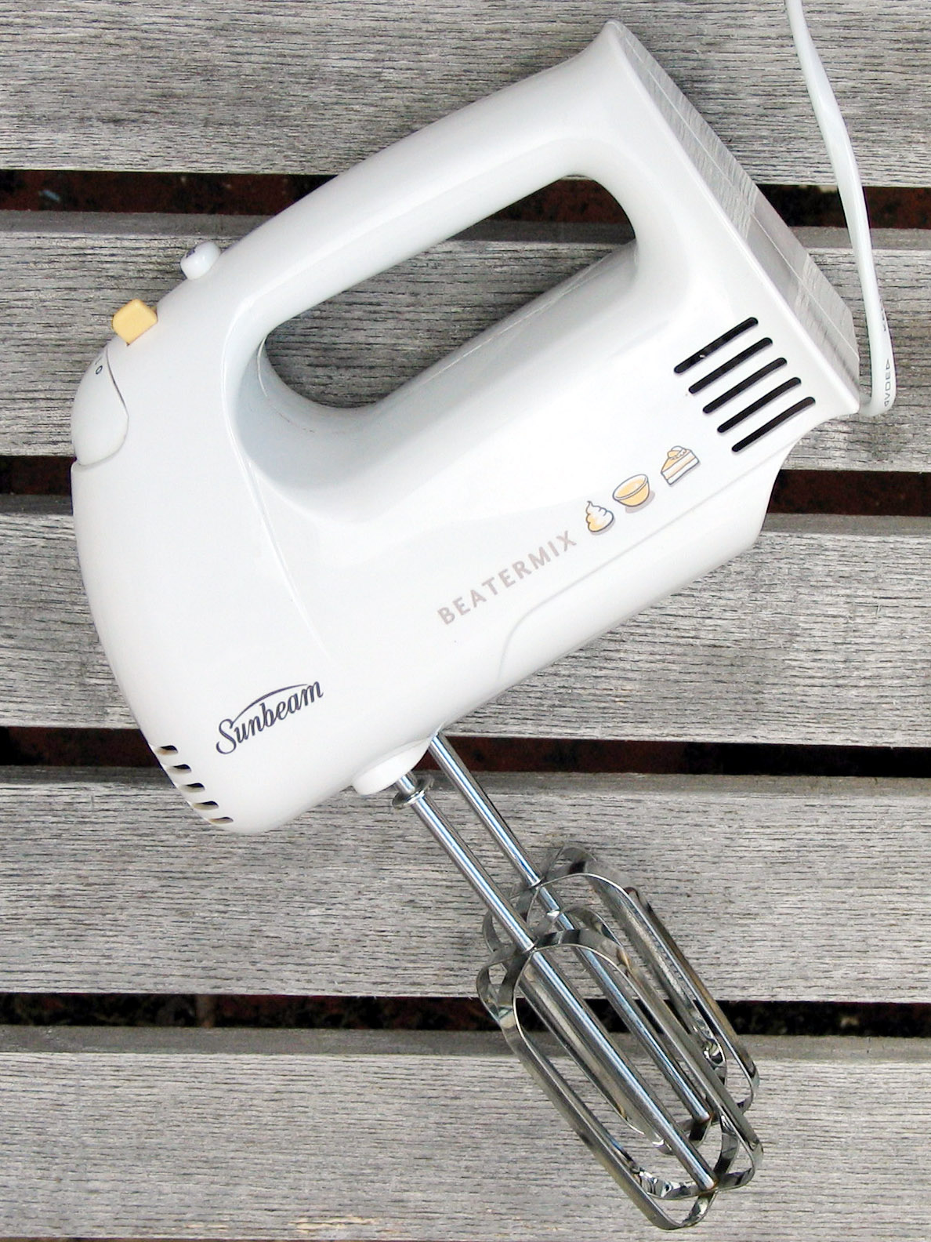 13. 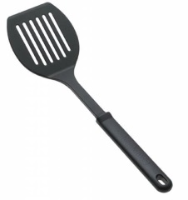 14. 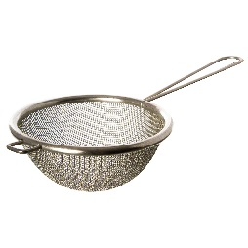 15. 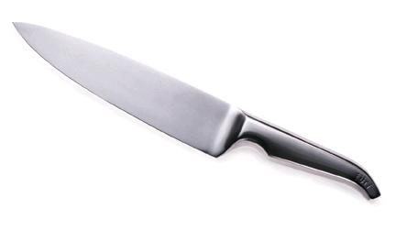

|  |  |
| --- | --- |
| NAME | USED FOR |
| 1. |  |
| 2. |  |
| 3. |  |
| 4. |  |
| 5. |  |
| 6. |  |
| 7. |  |
| 8. |  |
| 9. |  |
| 10. |  |
| 11. |  |
| 12. |  |
| 13. |  |
| 14. |  |
| 15. |  |