CLOTHING CARE TIPS WORDSEARCH

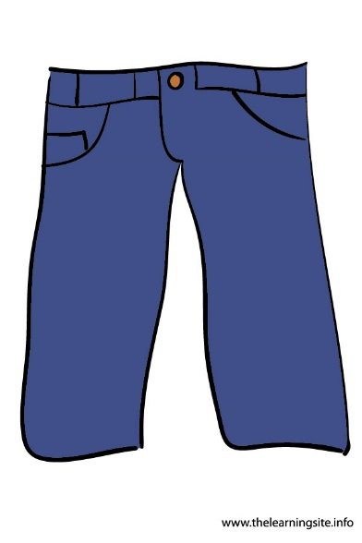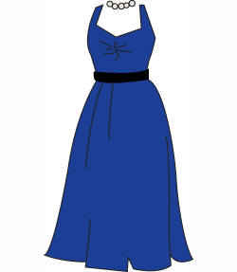

BAG H S Q C H S I K E N D S G N P
CARE M C R M L V L Q J E N W N G X
CLEAN G I Y E W O I L D H E E I R D
CLOSED L G X A G H S A I S C A T L G
DRYCLEANING M G M K A N O E E P N T R N Q
DRYER S O N Z O L A O D W A E O V N
GARMENT K U O I R L H H V A N R S F G
HAND S A N E N S G A B R E S V F Z
HANGERS R L V L U A S I L R T Q K S T
LABEL E O P U I H E U C W N H P C R
LINT N K P U E G P L B A I R T L T
MAINTENANCE A M E L D L H O C H A A M V P
MENDED Z Y V C A R E T K Y M A M L F
OVERLOADED D E P O L I S H U Y R P D H M
PILLS S D K B C J Y Y Y I T D U E E
POCKETS V A C W C R S H P D V Z X G N
POLISH N Q O S V H L M E L H L M B D
PROMPTLY Q O P R O M P T L Y A A R T E
SHELVES L C M Y J N A A F B V O N B D
SHOES J B F Q M M Y K E E L E N D L
SORTING R E Y R D Z U L X D M W A X I
SUNLIGHT Q R S T E K C O P R B A E J N
SWEATERS Q Z W G S U P P A J A Q L Q T
WOOL F X Z U H I X G B V V J C X X

